32.20: a) The electric field is in the 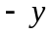-direction, and the magnetic filed is in the -direction, so 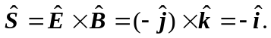 That is, the Poynting vector is in the -direction.
b) 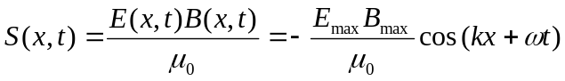
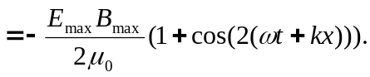
But over one period, the cosine function averages to zero, so we have:
|